Sending AT command in Legato application

# Using system() API

1. Import the following application inside Developer Studio



1. Please note that we need to disable the sandbox option in ATcmd_Test.adef in order to access AT command port in Legato application 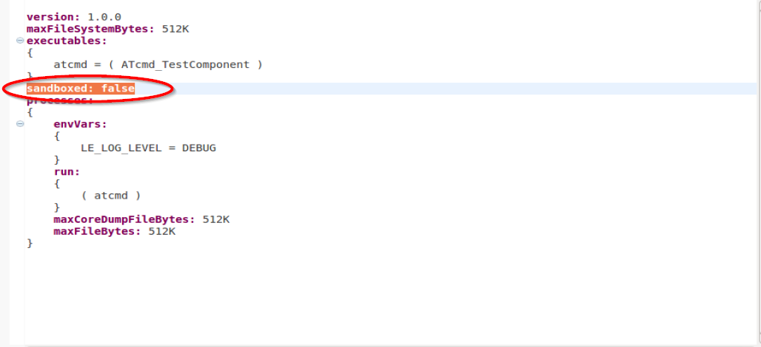
2. In ATcmd_Test.c, configure the WP8 phone number in

#define Phone_Number "97576275"

1. In WP8 console, enter “cm sms monitor &” to monitor the received SMS
2. Once the application is run, it will send SMS to itself.
3. You should see the following in the WP8 console:

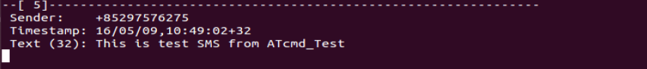

# Using open() API

1. Import the following application inside Developer Studio



1. Please note that we need to disable the sandbox option in ATcmd_Test2.adef in order to access AT command port in Legato application

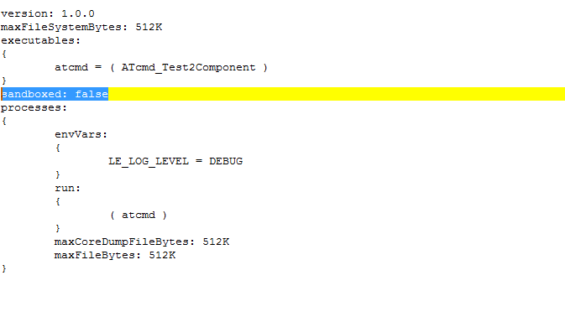

1. In ATcmd_Test2.c, configure the WP8 phone number in

#define Phone_Number "97576275"

1. In WP8 console, enter “cm sms monitor &” to monitor the received SMS
2. Once the application is run, it will send SMS to itself.
3. You should see the following in the WP8 console:

